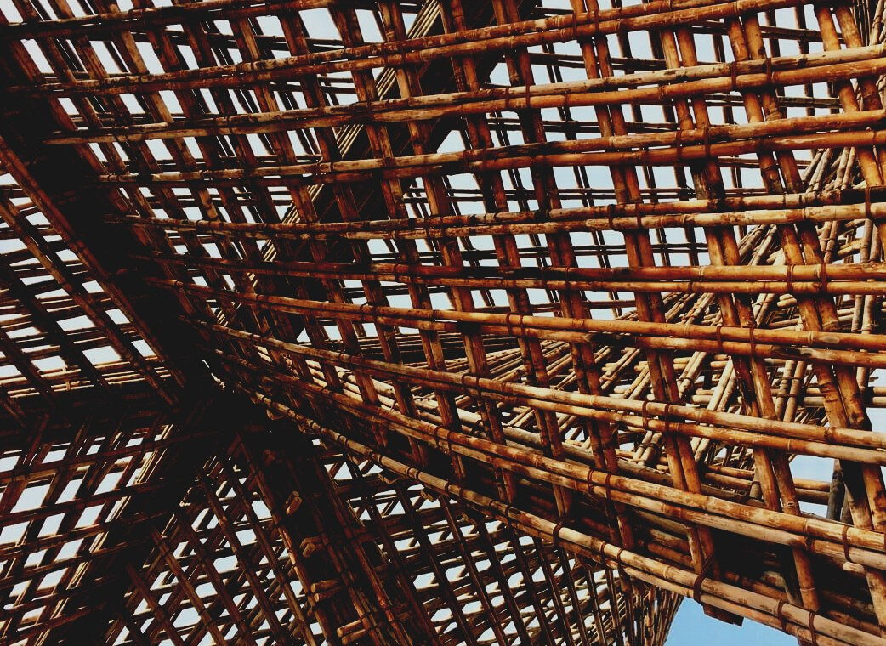

TRAINING MATERIAL

Learning Unit 3
GUIDELINES FOR TRANSPORTATION AND STORING
UPWOOD
Up-skilling construction workers in wood construction methods for energy-efficient buildings

UPWOOD-PUU
Rakennustyöläisten ammattitaito energiatehokkaiden rakennusten puurakentamisenmenetelmissä

Table of contents
1. Protection and local storage 2
1.1 Important in storing 2
2. Transportation 5
3. List of references 6

Protection and local storage
The protection of wood material during storage, transport, and interim storage are important because the wood material tends to equilibrate with the surrounding conditions. A poorly bonded or leaking rain cover moistens the surface wood, from where it is absorbed deeper into the wood material. An oblique base causes a warped body that is no longer easy to straighten.
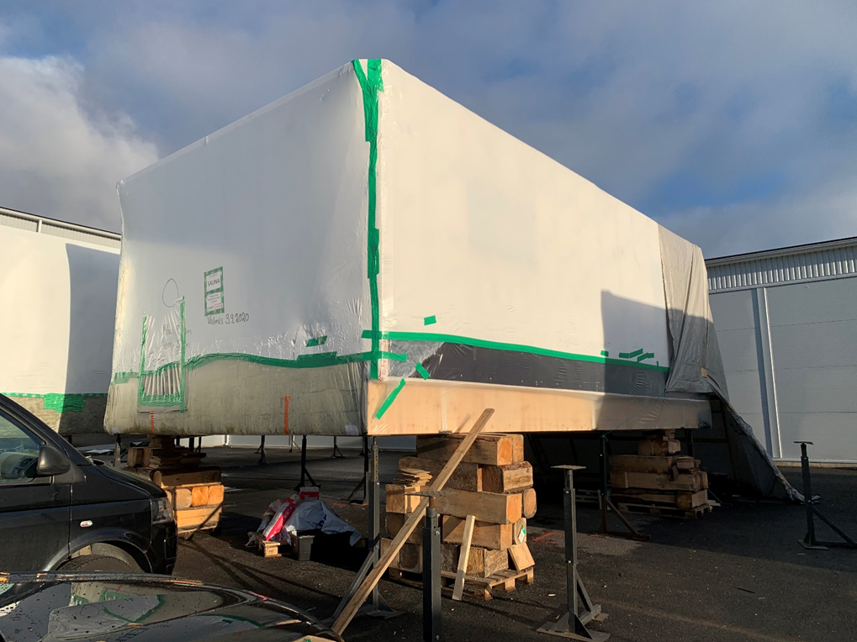
It must also be remembered that the wood material is highly absorbent, so dirty or rusty water stains the surface of the wood material deeper. The protection during transport must be able to withstand the pressure of the airflow and all corners, bumps and even small damage to the protective film must be taped, otherwise, vibrations during transport will break the protective film, and dust and water rising during transport will be absorbed into the wood material. Only the indicated lifting methods and points must be used for loading and the platform of the intermediate storage must be off the ground.
Image 1 The protective film used on module element © Elementti Sampo Oy

Important in storing
The aim is that the storage conditions should be as close as possible to the conditions during use. Outdoor building materials are stored protected from the weather and surface water, and materials that become warm inside are stored in warm indoor conditions. Poorly moisture-resistant materials are introduced up to the amount used during the shift, and special care must be taken to protect opened material packages during work. Dampened materials must be dried or replaced, and moisture-damaged materials must not be installed or used.
Workplaces, structures, and building materials that are exposed to rain are protected at the worksite to reduce moisture damage. The method of protection used is influenced by the location, shape, and susceptibility of the building to damage. The size of a building or structure affects whether the object can be completely covered or whether protection is implemented only part at a time.
The impact of the season on the protection of structures and materials is clear. In the autumn, the structures are protected from wind, rain, needles, and leaves falling from the trees, ground moisture rising from the warm soil after the summer, frosts caused by rain, and surface water flows.
In winter, problems are caused by snow loads, cold, freezing, slippage, wind-piled creeps, and the fragility of materials in cold air. In autumn rains, water pools created in the shelter material freeze, and the shrinkage material, which is brittle in the cold, cracks when the material is taken from under the shelter.
As spring approaches the ice mass, created on top of the cover during the winter, melts and the broken cover drains the water into the middle of the pile, watering the entire pile. Fortunately, the air is dry and even low humidity condenses on cold snow or ground surfaces, but problems are caused by snowmelt, slippery and muddy work areas, and strong UV radiation that easily stains the unprotected surface.
Summer brings fungal spores, strong winds, and rains raised by the thunder front, air humidity is high, and gravel and mud splashes raised by rain from the ground can stain low-stored materials. Birds are also looking for nesting and resting places, so bird droppings may be absorbed into the surface of a poorly protected structure.
Condensation of soil moisture on the structure, water used on-site (i.e. wetting during fire work) or water used to make building material can also create harmful water vapor during work, which is absorbed into the material or structure.
Materials and structures consider that the water absorbed in can escape freely from them. In some structures, the removal of bound moisture is too slow, and the material or structure has time to be damaged before drying, or the moisture has brought color, rot, or mold damage to the material. In such cases, the damaged materials are replaced and the structures to be stored are dried and protected from mold and rot damage.
The materials are protected from moisture by keeping them off the ground with sufficiently high washers. At the same time, it is ensured that the load-bearing subsoil or base is sufficiently compacted to support the weight of the material so that the materials cannot be distorted, and surface or meltwater cannot flood under the materials.
In addition, care is taken to ensure that the material is ventilated and that there is an air gap between the materials and the waterproof protective cover and the material, and that the protective cover remains securely in place.
Air contains a certain amount of moisture at a certain temperature. Thus, the water vapor content of cold air is low and that of warm air is high. Moisture tends to move in an ever-drier direction, so the moisture content of materials changes as the moisture content of the air changes.

Transportation
The different modes of transport are road, rail, sea, air, mail, express, and intermodal transport. In addition to the costs incurred and the vulnerability of the goods, the safety, timing, reliability, and punctuality of delivery must be taken into account when planning and implementing transports. The representatives of the buyer and the seller agree on the execution of deliveries, responsibilities, and obligations in the delivery clause and the mutual trade agreement.
Road transport is colloquially referred to as rubber wheel transport, which distinguishes it from land transport by rail. The popularity of road transport is influenced by intermodal transport (due to the widespread of industry and population), for which road transport is the only efficient and fast option that allows transport - even as a door-to-door service. Road transport is suitable for transporting a wide range of goods from packages to sea container transfers and special transports.
When choosing the mode of transport, the value, susceptibility, and properties of the goods to be transported must be considered, as well as the consignor's requirements for the characteristics of the transport. The most important are the urgency, size, and value of the transport, as well as where the goods are taken for transport and where they are exported (i.e. the exporting country). The characteristics of the goods to be transported, such as their appearance, characteristics, degree of processing, the dimensions and weight of the packaging, and the volume required for delivery, must be considered. Sometimes the goods to be transported must be subjected to interim storage or intermediate handling, or there are transport conditions, special requirements, or restrictions to be considered during the transport route.

List of references
Sahlstedt, S. Materiaalien suojaus työmaalla. Referred 2.1.2021. Available: https://www.rakennustieto.fi/Downloads/RK/RK140507.pdf
Valtioneuvoston asetus elementtirakentamisen työturvallisuudesta. 2003. 01.10.2003/578.
Sahlstedt, S. & Koskenvesa, A. 2016. Kuivana rakentaminen – Opas rakentamisen kosteushallintaan. Espoo: Mittaviiva Oy

