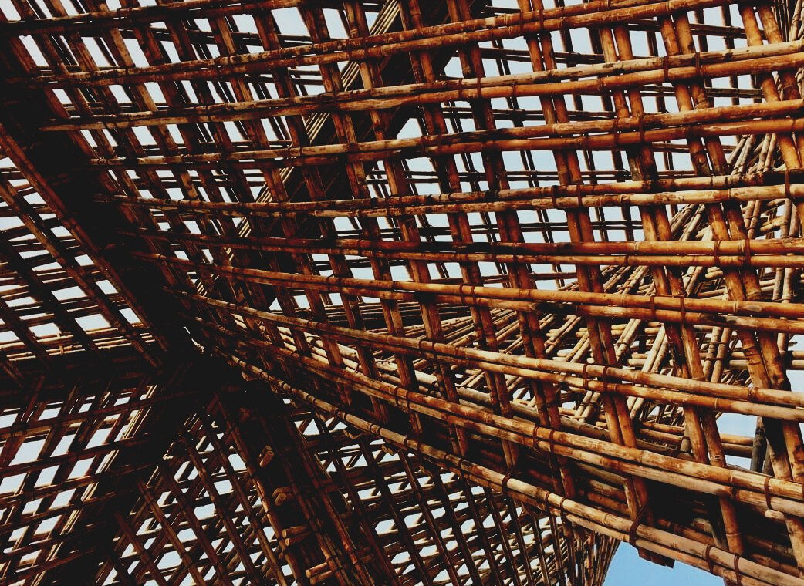

ASSESSMENT MATERIAL

Learning Unit 2
WOODEN TRUSSES
UPWOOD-PUU
Up-skilling construction workers in wood construction methods for energy-efficient buildings

UPWOOD-PUU
Rakennustyöläisten ammattitaito energiatehokkaiden rakennusten puurakentamisenmenetelmissä

Table of contents
1. Frequently asked questions 2
2. Multiple choice questions 3
3. Case studies 3
3.1 Case study 1 3

Frequently asked questions
Question: What things need to be considered while working on trusses?
Answer: Trusses are designed for use in an upright position, in which position they should also be transported. The installation and handling and support instructions are followed when installing the grilles. Trusses are usually supported on an overhanging tree placed aside or on its lap.
Question: What fasteners can you use to attach the truss?
Answer: The grid is attached with a single corner bracket using comb nails.

Multiple choice questions
- I-beams achieve the same load-bearing capacity with less material than glulam.
  - True
  - False
- Roof trusses or “NR trusses” are
  - made of sawn timber with skillful wooden joining techniques.
  - made of sawn timber with nail plate joints.
- A wooden truss is not a fire-rated structure if
  - it has unprotected nail plate joints.
  - the nail plate joints aren’t completely protected against fire.

Case studies

Case study 1
Name at least three different types of roof trusses.

