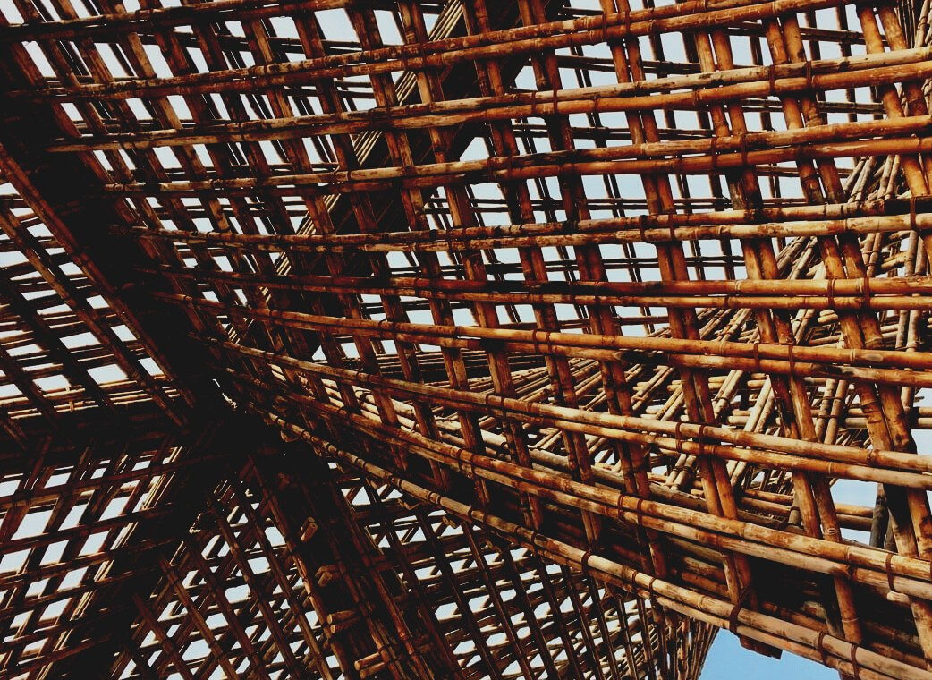

TRAINING MATERIAL

Learning Unit 2
THE USE OF CONSTRUCTION PRODUCTS
UPWOOD
Up-skilling construction workers in wood construction methods for energy-efficient buildings

UPWOOD-PUU
Rakennustyöläisten ammattitaito energiatehokkaiden rakennusten puurakentamisenmenetelmissä

UPWOOD
Rakennustyöläisten ammattitaito energiatehokkaiden rakennusten puurakentamisenmenetelmissä

UPWOOD-PUU
Rakennustyöläisten ammattitaito energiatehokkaiden rakennusten puurakentamisenmenetelmissä

Table of contents
1. Starting point 2
2. Environmentally friendly construction product 3
2.1 Doors 3
2.2 Windows 4
2.3. Standardized window types 5
3. Quality of installation 5
3.1 Windows 5
3.2 Doors 5
3.3 Module element 5
4. List of references 7

Starting point
Construction products are products that become an integral part of a building (for example, module elements, windows, doors, or roof trusses). The EU Construction Products Regulation applies to all construction products for which a harmonized product standard (hEN) has been applied or for which a European Technical Assessment (EEA) has been applied by the manufacturer. According to Section 4 of the Act on Product Approval of Construction Products, a construction product means a permanent building part, structure or a supply, product or device closely related to the construction site for which essential technical requirements have been laid down in or under to the Land Use and Construction Act. A construction product may also mean a part required for the installation of the above product.
Construction products must be safe and sustainable and must not be harmful to health. Construction products are suitable for use in construction if they meet the essential technical requirements laid down in the Land Use and Building Act concerning the strength and stability of structures, fire safety, health, safety, accessibility, noise control and sound conditions, and energy efficiency.
The CE marking facilitates the sale of products from one country to another and indicates the suitability of construction products if the product is covered by the hEN or the EEA. The CE marking ensures that the characteristics of products are always indicated in the declaration of performance in such a way that both designers and consumers can easily compare construction products.

Environmentally friendly construction product
It’s a good practice to use eco-labels to identify and choose an environmentally friendly product. The most common eco-labels in Finland are the Swan Label (Nordic Ecolabel) and the EU Ecolabel. The labels differ from many other brands by setting strict and unconditional requirements for manufacturing, as well as taking into account the entire product life cycle and its environmental impact (including energy consumption, indoor air emissions, and responsible forest management).
Many different construction products can already be found under the eco-label, such as exterior and interior paints, building boards, acoustic boards, various floor coverings from parquet to linoleum, and heat-treated. In other Nordic countries, eco-labeled construction products include e.g. eco-labeled windows.

Doors
As a general rule, the U-value of the external door must be ≤ 1.0 W / m²K. The lower the reading of the outer door U-value, the better is its thermal insulation. Closed exterior doors can have a U-value of up to ≤ 0.7 W / m²K, but glass-apertured exterior doors have a lower U-value, moving between ≤ 0.7-1.0 W / m²K.
In construction, doors must meet various requirements, such as type of use, place of use, method of opening, hinge, locking, fire resistance, thermal insulation (U-value), and sound insulation (dB value), as well as surface material.
The doors are made of vanes and press plates of different sizes, which react little to changes in air humidity and temperature. The structure of the door includes the door leaf, the frame, and the surrounding parts of the frame structure (for example, electric barriers), as well as hinges, locks, and other fittings as well as seals.
The most common doors include:
An exterior door is a door on the facade of a building that opens from its hinges and leads from the outside to the inside of the building. A window door is an external door with a glass opening.
A glass sliding door is a hinged, heat-insulated outer door that can be opened on top of a sliding rail, which is usually made with an aluminum frame and a large glass opening.
Balcony window doors have a more common aluminum coating on the outside, this product is also called a landscape door.

Windows
The heat transfer coefficient of a window or skylight must be at least 1.0 W / m²K. The window square usually transfers heat almost six times more than the outer wall square, especially if the frames and frames leak heat out more than the glass parts.
When installing a window, special care is required in tapping the gap between the window frame and the wall and in making the connection between the frame and the air barrier. Conventional new windows have 3 to 4 glasses, the best windows usually have 4 glasses, plus a selective film, as well as a heat-insulating gas (e.g. argon or krypton) between the sealed glass elements.

Standardized window types
- MS: 2-glass window, opening inwards only
- MSU: 2 glass window, opening both in- and outwards
- MSK: 3 glass window, opening inwards only
- MSE: 2 frame and 3 glass window, opening inwards only
- MS2E: 2 frame and 4 glass window, opening inwards only
- MEK: Fixed window glazed with a solid glass element
- SE: Single frame glazed with 2 or 3 glass elements, opening inwards only
- DK: Tilt-and-Turn window, can be opened both vertically or horizontally, opening inwards only

Quality of installation

Windows
Slots in the frames must be filled in such a way that the adjacent surfaces are not damaged, soiled, or discolored, and the cross-section must be ensured when the window is closed, and the opening must also be perfect. Window fittings must be simple, safe, easy to use, and can withstand normal stress. The windows must be intact on the surface and there must be no stains, cracks, or other defects on the exposed surfaces.

Doors
The installation interval of exterior door frames should be tipped so that adjacent surfaces are not damaged. The installation interval of interior door frames does not need to be checked unless sound insulation requirements are set. Door mirrors must be intact on the surface and must not have any color variations that would impair the appearance, but wood-specific color variations are permitted. Pre-treated surfaces must be free of stains, cracks, or other defects. The permissible curvature of the door panels is usually ± 5 mm.

Module element
The module element is a torsionally rigid and transport-resistant, ready-made house block, so the construction time is significantly shortened, and the quality of construction is improved. The modules are ready-to-move-in apartments, the technology of which is connected from the stairwells to the system of the house, so the amount of work to be done on the site is reduced. At its best, the four-story apartment building will be ready to move in within six months of starting construction. The total area of the module element is a maximum of 46 m² and the maximum height is 3,4 meters.

List of references
Finland’s Ministry of the Environment website [read 15.11.2020]. Available: https://ym.fi/rakennustuotteet
Energiatehokas Koti website [read 15.11.2020]. Available: https://www.energiatehokaskoti.fi/
Rakennustieto. Uuden asunnon laatu. 2020. Helsinki: Rakennustieto Oy

