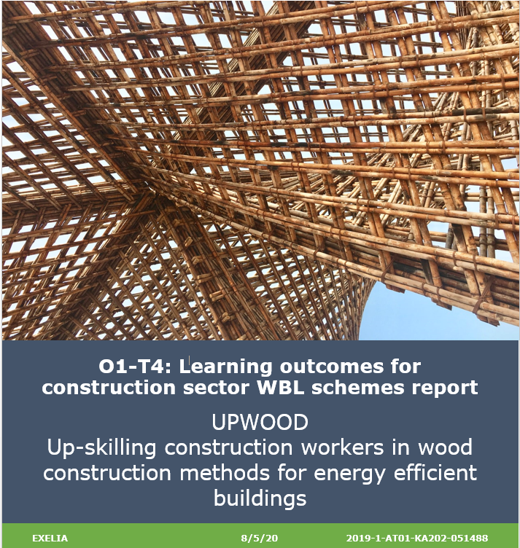
03/03/2221
UPV
O4 – T2: Position Paper to promote the quality of work-based learning within the construction sector
UPWOOD
Up-skilling construction workers in wood construction methods for energy efficient buildings
Project details
Project acronym: | UPWOOD
Project name: | Up-skilling construction workers in wood  construction methods for energy efficient  buildings
Project code: | 2019-1-AT01-KA202-051488
Document Information
Document ID name: | 2022-03-03_UPWOOD_IO4_O4-T2_Position Paper
Document title: | Position Paper to promote the quality of work-based learning within the construction sector
Output Type: | Intellectual Output 4
Date of Delivery:
Activity type: | Services/structures
Activity leader: | Universitat Politècnica de València
Dissemination level: | Public

Document History
Versions | Date | Changes | Type of change | Delivered by
Version 1.0 | 27/01/2021 | Initial document | - | UPV
Version 2.0 | 28/01/2021 | First review | Incorporation of Exelia's comments | UPV
Version 3.0 | 03/03/2021 | Second review and partners’ contribution | Incorporation of comments and input from all partners. | UPV

Disclaimer
The European Commission support for the production of this publication does not constitute an endorsement of the contents which reflects the views only of the authors, and the Commission cannot be held responsible for any use which may be made of the information contained therein.
The project resources contained herein are publicly available under the Creative Commons license 4.0 B.Y.

Contents

1. Glossary 4
2. Context of the UPWOOD Project 5
Scope of the project 5
Objectives 5
Innovative value added through the project 5
Partnership of the UPWOOD Project 6
Deliverables and impact 6
3. Purpose of the Position Paper 7
4. Target Groups of the Position Paper 7
5. Strategic communication plan 7
Expected impact and benefits on key stakeholders and actors 8
Identification of the Distribution Channels for the Position Paper 9
6. Deployment plan for the Position Paper 9

Acronyms and Abbreviations
ECVET | European Credit system for Vocational Education and Training
EQF | European Qualification Framework
ESCO | European Skills, Competences, Qualifications and Occupations
EU | European Union
EXELIA | Partner of UPWOOD Project (Exelia Consulting Services – Greece)
HCS | Partner of UPWOOD Project (Holzcluster Steiermark – Austria)
IO | Intellectual Output
KPI | Key Performance Indicators
LU | Learning Unit
LVT | Partner of UPWOOD Project (Liepajas Valsts Tehnikums – Latvia)
OER | Open Educational Resources
UPV | Partner of UPWOOD Project (Universitat Politècnica de València – Spain)
UPWOOD | Up-skilling construction workers in wood construction methods for energy efficient buildings
VET | Vocational Education and Training
WBL | Work-Based-Learning
WOODPOLIS | Partner of UPWOOD Project (Wood Construction Expert – Finland)

Glossary

Context of the UPWOOD Project

Scope of the project
Construction with wood yields high energy efficiency value, becoming increasingly in the construction materials market. Correspondingly, skills relevant to innovative timber constructing methods and applications are in high demand in the EU construction market. However, construction employers note a gap between the skills and knowledge acquired by workers and apprentices through Work Based Learning (WBL) in the woodworking skills needed in the workplace, stringent renovation requirements and policy measures seeking to stimulate the transformation of existing buildings and the fast-paced emergence of relevant new markets exacerbate this gap even further.
Up skilling construction workers with innovative timber constructing skills through work-based learning VET is therefore essential to meet the current and future demand for energy efficient solutions in the construction and renovation sector. The UPWOOD Project is a mechanism to achieve a competitive and increasingly sustainable labour market in this field.

Objectives
The UPWOOD project is a European project co-funded by the Erasmus+ programme for the period 2019-2022 with a partnership of 5 organisations from 5 countries, focused on:
- Developing new training content on energy efficient timber constructing methods and applications.
- Developing teaching materials, VET integration guidelines, and trainer’s guide to support VET providers to integrate new woodworking construction technologies and processes into their WBL and apprenticeships offerings.
- Improving cooperation between VET providers and businesses to provide opportunities that will enable learners to apply the acquired knowledge and skills in real-life workplace situations.

Innovative value added through the project
The project will offer a novel VET programme on new technologies and applications of wood in construction, aiming to support the professional development of construction sector professionals with a new set of skills and competences that are in shortage within the labour market. UPWOOD will create Open Educational Resources (OERs) and offer the curriculum in the format of online training scenarios to support informal learning and personal learning pathways, as a means to reach individuals reluctant or unable to participate in continuous training activities. Scenarios will be designed to simulate real-life working situations, applicable to all types of construction. In addition, learning outcomes approach have been adopted in order to connect the developed VET programme with the European Frameworks (EQF, ECVET).
Finally, the development of this VET programme will contribute to the formation of common content for innovative technologies and energy efficient woodworking applications, promoting recognition and standardisation, to allow cross-border mobility of workers and apprentices.

Partnership of the UPWOOD Project
- Holzcluster Steiermark (HCS): Leading cluster in Graz, Austria, developing and implementing projects along the Wood value chains, with special focus on timber construction.
- EXELIA: Creative learning solutions company based in Athens, Greece specializing in vocational training with innovative methodologies
- Liepajas Valsts Tehnikums (LVT): Prestigious technical education school in Latvia, provides professional education programs, including construction and woodworking.
- Universitat Politècnica de València (UPV): Public academic institution dedicated to researching and teaching in the field of construction technologies in Valencia (Spain).
- Woodpolis: Expert organization providing training and product development services for Wood construction, located in Finland.
Activities and methodology
The UPWOOD Project entails the development of the following activities and methodology related to innovative energy efficient woodworking construction:
- Development of VET Learning outcomes for training provision validated by trainers and field experts and creation of the structure of a curriculum on innovative energy efficient woodworking construction methods and applications, and VET integration guidelines.
- Creation of Open Educational Resources (OERs) for training constructions sector professionals and apprentices.
- Development of online game through practical scenarios infrastructures and content for sector professionals and apprentices.
- Establishment of a framework for the recognition/validation of the UPWOOD units of learning outcomes and integration of energy efficient woodworking skills requirements into the EU certification and standardisation schemes.
- Organisation of five national information days in Austria, Latvia, Greece, Spain and Finland to share and disseminate UPWOOD results.

Deliverables and impact
The following results and impact are expected to be reached in the UPWOOD project through the multiples deliverables stated as follows:
- The UPWOOD learning outcomes (Intellectual Output-1) for training provision in environmentally friendly and energy efficient innovative woodworking constructions practices validated by trainers and experts (to reach 50 VET providers and 100 construction employers).
- All learning materials are designed to be offered as Open Educational Resources (OERs) for unrestricted third-party use (to reach 350 learners). The curriculum consists of four learning units (IO-T2) and Online Training Scenarios (IO-T3).
- Research for the identification of innovative energy efficient woodworking skills requirements for construction workers (125 stakeholders).
- Pilot session to validate UPWOOD learning outcomes/units and educational resources (100 participants).
- Five national Information Days to promote and disseminate UPWOOD project results (300 participants).
- A Position Paper (IO-T4) to support decision-making and promote the integration of energy efficient woodworking skills requirements into occupational standards (75 policymakers/stakeholders).
- UPWOOD learning outcomes developed in European languages (6 languages).
- Social media outreach and engagement (100 people per network, 10 engaged users per post) and UPWOOD dissemination activities to share project results and progress (5.500 people in total).

Purpose of the Position Paper
The Position Paper aims to promote the incorporation of environmentally-friendly and energy efficient innovative woodworking construction practices into occupational standards for construction workers and professionals and influence decision-making towards enhancing WBL elements in VET provision, empowering cooperation between VET providers and employers, providing incentives for construction employers to engage in WLB, promoting the establishment of skill development policies and strategies.
This document along with the Statement of support, the Certificate Supplement and the network created thanks to the dissemination activities carried out during the project consolidates a link between the partnership, VET providers, employers, and policymakers to prepare the necessary cooperation framework for the integration of project materials and the standardisation of construction sector energy efficiency woodworking skills requirements into construction sector WBL curricula and certification schemes.
Finally, to promote the supply and quality of work-based within the construction industry, the UPWOOD project offers a combination of pedagogical resources validated by sectorial stakeholders involved in WBL that will help construction sector apprentices and workers up with the latest developments and trends in the sector and enhance their employability since they are based on research on current and future training needs and workplace requirements and on the other hand, are in line with the EU certification schemes.

Target Groups of the Position Paper
This document aims to reach out policymakers (including National qualifications Agencies, Sector Skills Councils, Standard Setting Organisations, National Coordination points and local/regional/national career guidance bodies) as well as associations, VET & Work-Based Learning providers, networks, social partners active in the construction sector.

Strategic communication plan
This section aims to address the main target groups of the project and, in particular, this document, to explain the expected impact on each of the groups as well as the proposed communication strategy to reach them in a successful way.

Expected impact and benefits on key stakeholders and actors
As stated in the scope of the document, the main stakeholders of the position paper are associations, networks and other social partners related to the construction sector as well as policy makers at local, regional and EU level.
- Social Partners, associations and other networks
Social partners, associations, sector representatives, VET national and other networks will benefit from the development of a robust framework for the recognition of energy efficient skills in construction sector occupations, as the UPWOOD WBL curriculum design will be based on a learning outcomes approach, fully aligned with the European reference tools (EQF, ECVET, and ESCO).
In addition, the expected impacts can also be reflected through:
- The learning materials developed available as Open Educational Resources (OERs) suitable for post-project integration in:
a) Larger-scale inter-disciplinary and/or transnational programs targeted at construction sector occupations, carried out by educational organisations.
b) Training courses in other relevant sectors with partially common learning outcomes (construction materials, carpentry etc.)
- The development and application of up-to-date pedagogical tools such as the online training scenarios in order to train and serve as an example for similar initiatives in other sectors and disciplines after the project, fostering the transfer of innovation in VET.

- Policy Makers at local, regional and EU level
UPWOOD project seeks to support and influence the decision making of policy-makers during and after its duration. The project consists of an opportunity for policy makers to:
- Integrate WBL in the broader education and training systems and
- Provide a clear regulatory framework to ensure that employers provide valuable up skilling opportunities to professionals, facilitating their employability to the labour market.
- Deliver a statement of support and policy recommendations (through the position paper) in order to facilitate the adaptation or/and development of local, regional, national and EU policies specially as concerns:
- The integration of energy efficient woodworking skills requirements into occupational standards
- The improvement of the quality, supply and attractiveness of WBL.
- The partnership, though the application and validation of outputs following EU VET standards in different European countries, will provide evidence to support the exchange of best practices and cross-fertilisation of EU policies between national systems and organisations.

Identification of the Distribution Channels for the Position Paper
Among the different distribution channels, the National Information Days and the relevant social networks, as well as email campaigns have been identified.
The National Information Days should be organised by each partner in order to present the project’s objectives, activities, results, and outputs to the target groups of the partnership and, in particular, the Position Paper will be used to foster networking with stakeholders to be involved in the validation and endorsement of UPWOOD outputs. Each partner is responsible for the deployment of the Position Paper in the Information Day organized in its country, if possible.
Due to the COVID-19 pandemic situation, most of the events will take place online. This will facilitate the distribution of the event material together with the Position Paper to the target audience. In case the event takes place physically, the materials and the Position Paper can be distributed electronically or in physical format.
Another distribution channel will be the UPWOOD project's website, through which the position paper will be available and accessible to all stakeholders. In addition, the Position Paper can be distributed taking advantage of the other communication channels already mentioned in the Communication and Dissemination Plan, that includes both mediated, online means (such as the email campaign and social media pages: Facebook, LinkedIn, Twitter and Instagram) and direct, face-to-face interactions (such as personal contacts and networking in third party events).
The following section will analyse the potential distribution channels for each country in the UPWOOD consortium.

Deployment plan for the Position Paper
The Position Paper is deployed according to each partner as follows:
- EXELIA - Greece: The Position Paper will be disseminated at the national information day, along with other project results. In addition, it can be distributed as an email attachment, targeting all potentially interested stakeholders and policy makers already identified and contacted during the 4th and final dissemination campaign in Greece as well as in the posts in the social media through EXELIA’s networking channels (Homepage, Facebook, LinkedIn).
- Holzcluster Steiermark – Austria: The Position Paper will be included in the Post-event report to the information day, together with other materials developed, shared with the participants. In addition, it will be distributed as an email attachment, targeting all potentially interested stakeholders and policy makers already identified and contacted during the previous UPWOOD dissemination campaigns in Austria as well as in the posts in the social media through HCS networks channels (Homepage, Facebook, LinkedIn).
- LVT – Latvia: The Position Paper will be included in the dissemination materials for the information day In addition, it will be distributed as an email attachment, targeting all potentially interested stakeholders and policy makers already identified and contacted during the previous UPWOOD dissemination campaigns in Latvia as well as in the posts in the social media through LVTs networks channels (Homepage, Facebook, Instagram).
- UPV – Spain: UPV held the National Information Day on 18th November 2021 (UPWOOD website), the document will be sent to the participants who showed their interest in the project including the National Reference Centre for the Transformation and Installation of Wood and Cork (CRNFP). On the other hand, it will also be distributed to stakeholders included in the UPWOOD mailing list for the online dissemination campaigns, within the latest mailing campaign including VET Authorities, sector representatives, policymakers and associations. In addition, it will be shared on the social networks related to the UPV working group (HomePage, LinkedIn).
- Woodpolis – Finland: The Position Paper will be included in the invitation to the information day, together with other materials developed. The information day will be held online. In addition, it can be distributed as an email attachment, targeting all potentially interested stakeholders and policy makers already identified and contacted during the previous UPWOOD dissemination campaigns in Finland as well as in the social media through Woodpolis’ networks channels (Homepage, Facebook and Twitter).

