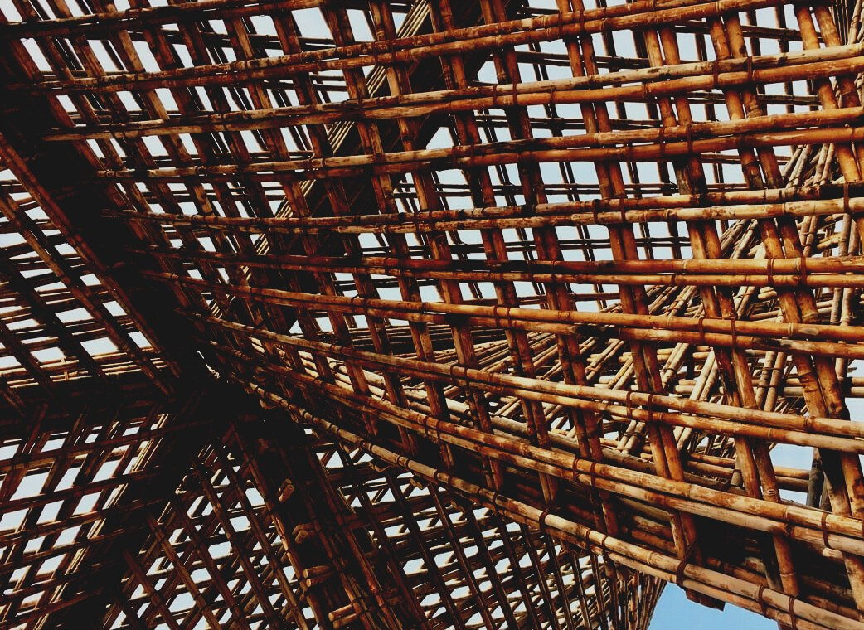

TRAINING MATERIAL

Learning Unit 2
PERFORMANCE AND DURABILITY OF WOODEN STRUCTURES
UPWOOD
Up-skilling construction workers in wood construction methods for energy-efficient buildings

UPWOOD-PUU
Rakennustyöläisten ammattitaito energiatehokkaiden rakennusten puurakentamisenmenetelmissä

UPWOOD
Rakennustyöläisten ammattitaito energiatehokkaiden rakennusten puurakentamisenmenetelmissä

UPWOOD-PUU
Rakennustyöläisten ammattitaito energiatehokkaiden rakennusten puurakentamisenmenetelmissä

Table of contents
1. Starting point 2
2. Strength of wooden structures 2
2.1 Compressive and tensile strength 2
2.2 Shear strength 3
2.3 Flexural strength 3
2.4 Buckling 3
2.5 Momentary and long-term loading 3
3. Frost 4
4. Hygroscopicity of wood 4
4.1 Moisture living 4
5. Load-bearing wooden structures 5
6. Load-bearing structures 7
6.1 Subfloor structure 7
6.2 Midsole 8
6.3 Upper floor support and water roof 8
6.4 Exterior walls 9
6.5 Pillar and beam structures 13
6.6 Wooden elements 13
7. List of references 15

Starting point
The basic function of a load-bearing timber structure is to transfer the dead weight, payload, snow load, and wind load to the foundation of the building. The joining methods used in timber structures must be determined according to the above-mentioned loads and joining methods are of key technical and architectural importance, as the wood material is inhomogeneous in structure and the properties of the wood vary depending on, for example, the base material, base or top log, or sawdust.
In wooden joints, two or more structural parts are connected so that, under the action of an external force, the joint prevents the parts from coming apart or sliding relative to each other. Making joints and joints in light-weight wood material is easy, which increases the use of wood in load-bearing structures. The durability of wood deteriorates if it is exposed to environmental stresses, such as rain, moisture, sunlight.

Strength of wooden structures
Variations in the strength properties of wood must be taken into account when designing wood structures. Official standards precisely define the values at which timber structures are dimensioned in design. These strength values determine what wood, under different stresses, can withstand with sufficient strength. The actual breaking strength of the wood is higher than the strength values of these norms.

Compressive and tensile strength
The strength of wood is better in the direction of grain than in a perpendicular direction. In structures, the tensile strength in the direction of the grains of faultless wood is generally better than the compressive strength. The wood in the direction of the grain is almost inextensible under tensile stress, while when compressed it yields and compresses. In compression perpendicular to grains, the strength depends on whether the compressive force is applied to the whole surface (total pressure) or to a part of it (rail pressure or stamp pressure).

Shear strength
Shear strength means that the shear stress tends to split in the part near the support of the wooden beam along with the causes of the wood.

Flexural strength
The bending strength of timber is due to the compressive and tensile strength of the wood. Since both tensile and compressive strength depends on the direction of grains of the wood, defects in the wood, etc., the bending strength also varies according to these. For example, the debilitating effect of a branch at the other edge of the beam can be reduced by turning the beam so that the branch is on the compressive stress side.

Buckling
Buckling means that a compressed structure can lose its stability. Slim and long structures, such as wooden pillars, often have to be dimensioned according to the risk of buckling. Deflection is prevented by making the component sufficiently thick or by supporting it with lateral ties.

Momentary and long-term loading
After a momentary load, the deflections of the wood can be restored. Long-term loading causes permanent deflections in structures subject to humidity fluctuations. In addition to deformations, the load time also affects the strengths of the wood. the time effect depends on the type of loading and the defects and moisture of the timber. Wood can withstand an instantaneous load of more than 50% more than a continuous load. The strength property and structural property of wood affect the fatigue strength of wood.

Frost
In winter, when the temperature drops below 0°C for a long time, the moisture and water bound to the soil freeze, causing the moisture-containing soil to expand by about 9%. This is called frosting, and poorly frost-protected structures move and even break. Prior to this, the resort had a foundation made of natural stone and a blocked log structure that withstood small movements caused by frost rising without significant damage. With the generalization of concrete plinths, slab-reinforced wooden walls, and masonry stone walls, the immobility of foundations became important. However, wooden buildings can withstand small movements of foundations, this is affected by the lightness of wooden buildings.

Hygroscopicity of wood
Wood is a hygroscopic material that strives for equilibrium moisture with the surrounding moisture. This leads, for example, to an increase or decrease in the humidity of the indoor air according to the humidity of the air in the wood material, whereby the hygroscopicity of the interior cladding smooths out the variations in indoor humidity and improves the quality of living. Wood is not yet used on a large scale for this purpose.
The binding of moisture to wood-based interior cladding materials lowers the peak values of indoor air humidity diurnal variation and improves the quality of the experienced indoor air, thus reducing the need for mechanical ventilation and saving energy compared to room vapor-impermeable materials.

Moisture living
Structures usually have to consider the survival of wood-based panels as well as the wooden frame under the influence of moisture. This requires a 1-10 mm shadow seam at the joints of the panels, at the floor-ceiling boundary, at the corners of the wall, and the joints of the window and door frames. Wood panels can also be joined with joints. Fiberglass tape glued over the seam reduces the adverse effects of board movements on the walls. If butt seams are used on exposed plate surfaces without covering seam tape, the edges of the plates must be chamfered. The boards are fastened with sufficiently dense nails or screws at the edges and in the middle of the tree trunk.

Load-bearing wooden structures
Load-bearing wooden structures can be divided into two different groups, horizontal structures (beams, tiles, and trusses) and vertical structures (walls and pillars). The beam carries loads on it from structures, furniture, people, etc. The beam must be able to withstand, except a small deflection, the loads coming on it and move them to support its supports. Loads cause stresses in the beam. Wooden beams are usually dimensioned according to the maximum allowable deflection and not according to the breaking strength. The height and span of the beam mainly determine how much the beam can withstand the load. Tensile stress is generated on the convex side of the beam and the concave side of the compressive stress. Shear stress is usually generated most at the supports. When the beam continues constantly over two or more openings, a continuous beam is formed from the structure. The resulting distributions of tensile stresses cause the stresses to be reduced and the deflections to be less. The loose beams can be bent individually, but by fastening the beams firmly together, the whole structure is made to function as a single continuous beam.
The joints of the beams can also be made in part of the opening by using steel-structured articulated connectors in the connectors. In this way, the deflections of the articulated beams remain the same as with a continuous beam of a similar size. Wooden beam structures include glulam, veneer, web board, lumber, and finger joint beam. If timber is needed in the structures for so long that it is not available, finger-extended timber can be used. In the finger joint, finger-like notches are machined at the ends of the timber, which are joined together with special glue. This enables the production of extra-long timber.
In wooden structures, timber can be attached in different ways. The connection method is selected according to the timber sizes to be attached and the stresses on the connection. The methods of joining load-bearing wooden structures are wood, nail, bolt, and dowel joints.
Load-bearing wooden structures made with nail plates and glued joints can only be manufactured in industrial plants equipped with the required equipment. The joining of the timber can be ensured by various notches made in the trees. A shoulder joint can be used for direct extension or a nail joint for the diagonal joint. the use of wooden joints in modern construction has remained low.
The joints used in load-bearing structures must be made in accordance with the construction plans. In addition to the main dimensions, they specify, among other things, the strength classes of the wood and the sizes and quantities of nails, bolts, and dowels at each joint, as well as diagrams of the exact placement of the connectors. In rods of a compressed structure, the ends of which are precisely matched to each other, part of the compressive force can be assumed to pass from one rod to another with the butt and the rest of the force is received by connectors, for example, a nail joint under compressive stress.
In a joint dimensioned according to tensile stresses, the forces are always transmitted only via the connectors, for example, a dowel joint under tensile stress. Bolted joints are rarely used in load-bearing structures. Dowel joints are used in joints of solid timber when the joint transfers high forces and the displacement of the joints must be small. Today, large beam structures are made of glulam beams, eliminating the need for dowel joints.
The structure of the truss is based on the resistance of its joints to the sliding tendencies caused by the compressive and tensile stresses of the components on the joints.
The pillar is a vertical structure attached at its ends, but otherwise unsupported. The pillar carries the loads on it, usually transmitted by the beam. The column is mainly stressed by vertical compressive forces. Due to the slenderness of the column, the strength of buckling is crucial for its strength.

Load-bearing structures

Subfloor structure
The design of the load-bearing subfloor structures (1) is decisively influenced by the method of installation and the number of foundation walls, beams, and columns, as well as the mutual distance.
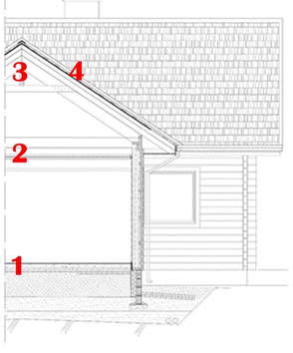
The load-bearing structures and foundations of the subfloor are interconnected. Therefore, they should be selected at the same time.
The beams carrying the lower midsole may be
a) solid sawn timber beams
b) glulam beams
c) veneer beams
d) thin-core plate beams
e) truss or grate beams
When using solid lumber as load-bearing beams for the subfloor, spans longer than three meters should be avoided. It is recommended to use plywood, fiberboard, glulam, or veneer beams as floor beams at intervals of 4 to 5 meters. Grate structures (load-bearing beams crosswise) increase the rigidity of the subfloor structure.
In the installation of beams, special attention is paid to selecting the best beams from the wood batch reserved for the purpose of the most stressed objects in the structure. When using strength-rated timber, the beam is installed in the structure so that the stronger edge of the stamped beam comes to the tensile stress side of the structure.
The distance between the floor beams often causes the floors to sag, which in turn causes vibration. The design of floor structures according to the design guidelines for wooden structures is not always sufficient, the reason is not the load-bearing capacity of the beams but the vibration. Deflection (perceived as a harmful vibration) caused by a point load, such as walking, in the floor structure can be prevented by increasing the stiffness of the floor.

Midsole
In the dimensioning and stiffening of the load-bearing beams of the floor and the design of the surface structure, attention is paid to the load on the top, the length of the load-bearing beams, their mutual distance, and the type of beams used. Minimization of deflection and vibration is essential in the dimensioning of the midsole beam (2). Solid timber usually does not reach spans longer than 4 to 5 meters. Veneer wood and wood-paneled beams make free lengths of up to 6 meters possible. Glulam beams do not place restrictions on the free span.

Upper floor support and water roof
Solid beams, glulam beams, veneer beams, lightened web beams, and roof trusses are suitable for supporting the upper floor (3). Glulam beams can also be used as primary supports in the operation of solid, glulam, and veneer beams as secondary supports.
In addition to operating and self-loading, the most important factors in the dimensioning of upper floor beams are snow and wind loads. When using veneer and web supports, the maximum span is about 7 meters. for glulam and roof trusses, the span does not normally impose technical restrictions but can reach spans of up to several tens of meters. In some cases, the structural height of the glulam beam may impose restrictions on the maximum span. By combining wood and steel, the roof supports can be lightened, and the span extended. Roof trusses are moving to nail plate joints (NR roof chairs), which should be made of planed lumber.
The water roof (3) protects the building from weather stress and affects the appearance of the buildings. It usually consists of a roof cover, a cover, and a roof base. A weatherproof porous fiberboard is best suited for wind protection. Snow loads can usually accumulate on the roof of the water, usually about 1.4kN / m2 to 2.6kN / m2. Water roof structures must withstand this weight without bending too much. In addition to the snow load, the water roof and the top floor structures accumulate their weight to be supported by the walls. The load on the walls is again transferred to the foundations, where additional weight is accumulated from the subfloor and the payload. In addition to the snow load, the wind load usually accumulates 0,5–1,0 kN/m² on the water roof.
Water structures have varied in different eras, wood, moss, straw, and peat have been used. Even today, a small number of shingles made of spruce, aspen, or pine logs are used to cover buildings. Common and long-lived margins were sludge and firewood margins. Wood and wood-based panels are currently used mainly as support structures for roofing materials of other materials, as a roofing base for cream coverings, and in connection with and underlayment.

Exterior walls
The most commonly used wooden walls (4) can be grouped according to their structure: horizontal log walls, frame walls, vertical log walls, truss walls, and frame walls.
The effect of weather on the exterior cladding
Facades are burdened by climate solar radiation, rain, snow and ice, wind, air humidity, and temperature fluctuations, and pollutants. The magnitude of the stresses is affected by the geographical location of the building, the height of the terrain, the orientation, and height of the façade, the environment, and the width of the eaves. Especially in open places and on the coasts, the south, southwest, and west walls of buildings are particularly exposed to the sun, wind, and sloping rain.
Windbreak
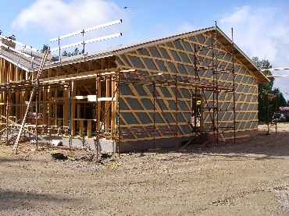
From the point of view of the moisture and thermal performance of the upper, the best wind protection materials are hygroscopic wood-based products, such as moisture-resistant and weather-resistant porous fiberboards. At the same time, they are effective additional thermal insulators.
Moisture insulation
Inflatable wood fiber secretions, like other wood-based products, have the ability to absorb and release moisture, i.e. they have a good moisture capacity. They equalize e.g. in roof structures, the humidity of the ventilation gap and the attic space, that the maximum humidity of the air space decreases. In this case, the risk of mold and decay due to the condensation of moisture on the surface of wooden support structures is reduced. This inherent moisture variation does not affect the thermal insulation properties of the wood fiber insulation.
Also, a porous fiberboard is a highly hygroscopic building material that can bind itself without water vapor or release hygroscopically bound moisture as vapor back into the air as the relative humidity of the environment changes. When a fiberboard interacts with room air, it has a so-called moisture buffering effect. This means attenuation of the relative humidity variation of the room air based on the moisture-binding capacity of the indoor panel cladding limiting the room space, compared to the same room space, the same varying indoor humidity load, and the same ventilation but not hygroscopic moisture binding to structures.
The water vapor in the room air should be able to easily penetrate the hygroscopic cladding material, so the vapor resistance of the inner surface of the porous fiberboard should be low. The shape of the sorption curve of the wood fiberboard, the high-water vapor permeability of the material, and the sufficient mass ensure that the board contributes effectively to the damping of moisture fluctuations throughout its thickness.
Panel cladding (exterior and interior cladding)
Types of plywood used in facades include birch plywood made of birch veneer with both birch, and softwood veneers, and softwood plywood made of softwood. The use of building boards in interior cladding consists of fiberboard, particleboard, and plywood. Semi-rigid, i.e. structural fiberboard, and porous fiberboard are used as internal cladding for wood fiberboards. Porous fiberboard with a fire-retardant treatment can be used in interior cladding. Particleboards are used as partition board cladding. Birch plywood and softwood plywood are used in interior cladding. In dry interiors, the moisture resistance of plywood is low. Plywood is also suitable for curved wall surfaces. However, a small bending radius easily causes hair cracks on the surface of the plate.
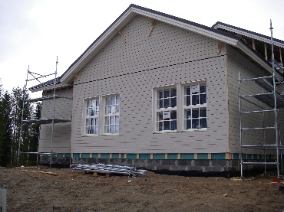
Exterior cladding
The best aspects of wooden cladding are durability, low maintenance, and plenty of appearance options. The wood is elastic in nature and formable. In a wooden building, the wood cladding should be the dominant entity, possibly complemented by other materials. Different façade materials should not normally be blended with coloring.
Interior cladding
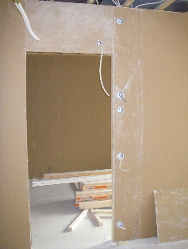
Plasterboard and particleboard are more commonly used for interior cladding. Other types of boards are softwood, plywood, semi-hard fibreboards, and 25mm porous fibreboards used in eco-houses. The surface of the boards can be painted or clad. At the same time, the surface plates often also function as part of the internal vapor barrier.

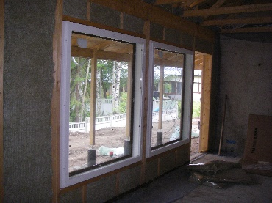
Thermal insulation
Wood fiber insulation is used as thermal insulation in wooden walls, porous wood fiber boards, which are used for wind protection or interior cladding, can slightly improve the thermal insulation of the wall.

Pillar and beam structures
In buildings where the load-bearing structure is made up of columns and beams, the structure of the wooden external wall is in principle similar to that of the load-bearing external walls. The non-load-bearing wall structure makes it possible to split the frame posts less often and, if necessary, also the horizontal frame. The load-bearing pillars are placed either inside or outside the wall.

Wooden elements
Element construction aims to rationalize the industrialization of the construction process. the construction is moved inside to warm, bright spaces, allowing you to achieve optimal use of building materials, such as glue and nail board joints and controlled work performance. Wooden elements can be used to assemble either the whole house or parts of it. Prefabricated buildings include prefabricated walls, roof trusses, and often roof and floor elements.
Seams between elements are important in element construction. Particular attention must be paid to their design and implementation.
The joints between wooden elements are subject to the following requirements, among others:
1) The seam must remain tight despite the small movement of the elements and the natural curvature of the wood.
2) The seam must be easy to seal and inspect.
3) The joint must be such as to prevent toothing due to the different curvature of the parallel elements.
4) The joint must not significantly slow down the installation, even if the element has dimensional deviations.
5) The seam must not form a cold bridge or allow air leakage.
6) The connection structure should be simple and inexpensive and should contain as few accessories as possible.
7) The joint must naturally receive the incoming and outgoing loads. Potential coercive forces, such as heat and moisture movements, should be small.

List of references
Kavaja, R. 2011. Rakennuksen puutyöt. 14th edition. Rakennustieto Oy
Siikanen, U. 2008. Puurakentaminen. Rakennustieto Oy
Suomen Tuulileijona website [referred 2.11.2020]. Available: https://www.tuulileijona.fi/
Puuinfo website [referred 2.11.2020]. Available: https://puuinfo.fi/
SFS-EN 1990 Eurocode. Basis of structural design. Helsinki: Finnish Standard Association SFS ry.
SFS-EN 1995-1-1 Eurocode 5. Design of timber structures. Helsinki: Finnish Standard Association SFS ry.
SFS-EN 1995-1-2 Eurocode 5. Design of timber structures. Helsinki: Finnish Standard Association SFS ry.
SFS 5978 Puurakenteiden toteuttaminen. Helsinki: Finnish Standard Association SFS ry.

