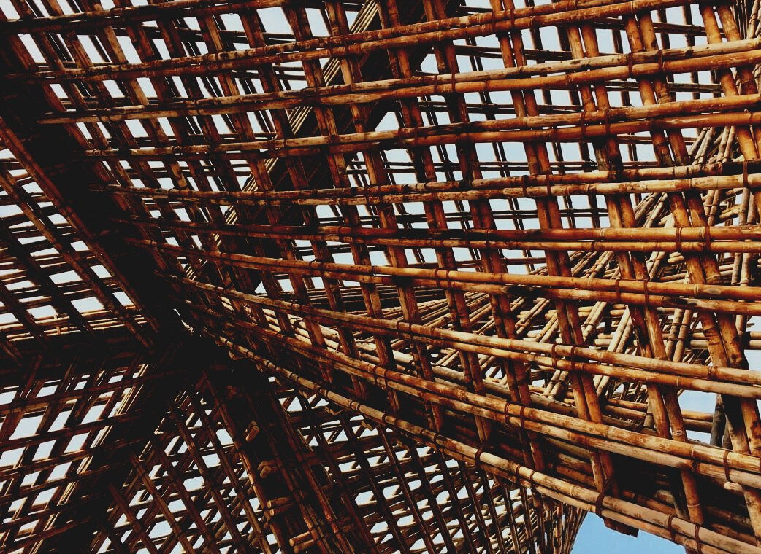

TRAINING MATERIAL

Learning Unit 3
WORK PLANNING AND TEAM MANAGEMENT
UPWOOD
Up-skilling construction workers in wood construction methods for energy-efficient buildings

UPWOOD-PUU
Rakennustyöläisten ammattitaito energiatehokkaiden rakennusten puurakentamisenmenetelmissä

Table of contents
1. Introduction 2
2. Work planning 2
3. Informing about construction site 4
4. Weather protection and humidity control 5
5. Work management 6
6. List of references 8

Introduction
The person undertaking the construction project must lead and direct the project as a whole, which considers both the project planning, procurement, and the time that needs to be required for the construction phases.
The functions of the various construction phases and the order of construction are key issues in construction management, so the dependence on the timely completion of the various work phases must be related to the project schedule, which also takes sufficient time into client decisions and regulatory processes.
Right at the beginning of the project, an agreement is reached on how the content of the design will be produced, controlling quality and schedule.
Today's data modeled projects determine data modeling practices to the extent that the modeled data and information are available to the project, e.g., in calculation, prefabrication, construction, and supervision.

Work planning
The site will be divided into blocks and sub-sites that will be taken to schedules. From the place-time diagram, the work management during working hours follows in which sub-object the workgroup is working on. When a workgroup works in a subsite at a time, the agents have peace of mind and thus high-quality work can be ensured.
The schedule includes tasks, accomplishments, workgroups, and task durations.
When measuring the duration of work steps, weather conditions are considered. The foundation and framing phase is timed to the driest possible season, but if this is not possible, the framing phase must be prepared for protection, drying, and heating work, in which case the effects of weather conditions and the drying times required by the structures must be taken into account in the schedules.
Features of a good schedule
- The object is designed in blocks
- The site schedule is a site schedule for critical tasks
- The technical works have also been dimensioned and coordinated with the technical works
- The tasks have the correct technical order of implementation
- Tasks are synchronized and rhythmic
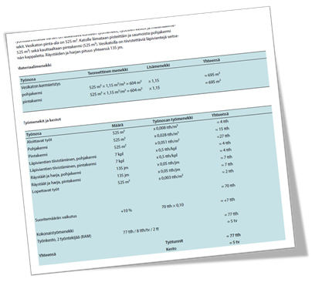
- The tension of labour costs is at a normal level (RATU)
- The tasks have a reserve job and only one job is done at a time
- The drying times of the concrete and the boundary conditions of the contract program have been considered
- Decision Support System (DSS)
Various ready-made workflow cards or calculation models are available for dimensioning special stages, for example, the RATU card system in Finland.
Image 1 RATU 0431. Page 20. © Rakennustieto Oy
Examples of calculation formulas
Required workgroup: (Number of tasks x labor requirement) / Duration
Duration of task: (Number of tasks x labor requirement) / Workgroup
Job availability: (Workgroup / labor requirement)
The normal duration of a project, i.e. the physical construction time (TN) in months, is calculated for large sites (total number of working hours over 10,000 employee hours (also labor requirement in working hours) using the formula:
TN = 4.6 x ln (total number of project hours) - 35.0
Plans arriving at the site should be reviewed and feedback is given to designers if they need to be corrected or supplemented. Design details that have been found difficult can be brought up at site meetings and site tours, in which case designers and contractors bring their expertise to design solutions.

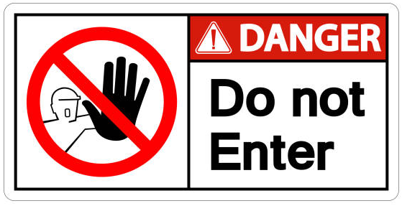
Informing about construction site
Information about the construction site is provided utilizing site signs, pre-advertisements, and a construction site table. Site signs warn of construction work and direct inappropriate people in the area to walk around the site.
The site shall be demarcated by a fence or other clear means from other land and erected site plans shall be erected before the commencement of the works, which shall be kept at the site until the completion of the works. The site plan shall be positioned so that it is easy to read and without endangering traffic.
The site plan includes the following:
- Site or project illustration or plan drawing
- Name and address of the construction site
- The content of the work
- Date of completion of the work
- Building permit code
- Builder
- General contractor and site contact information
- Designers
- Financial and insurance information

Weather protection and humidity control
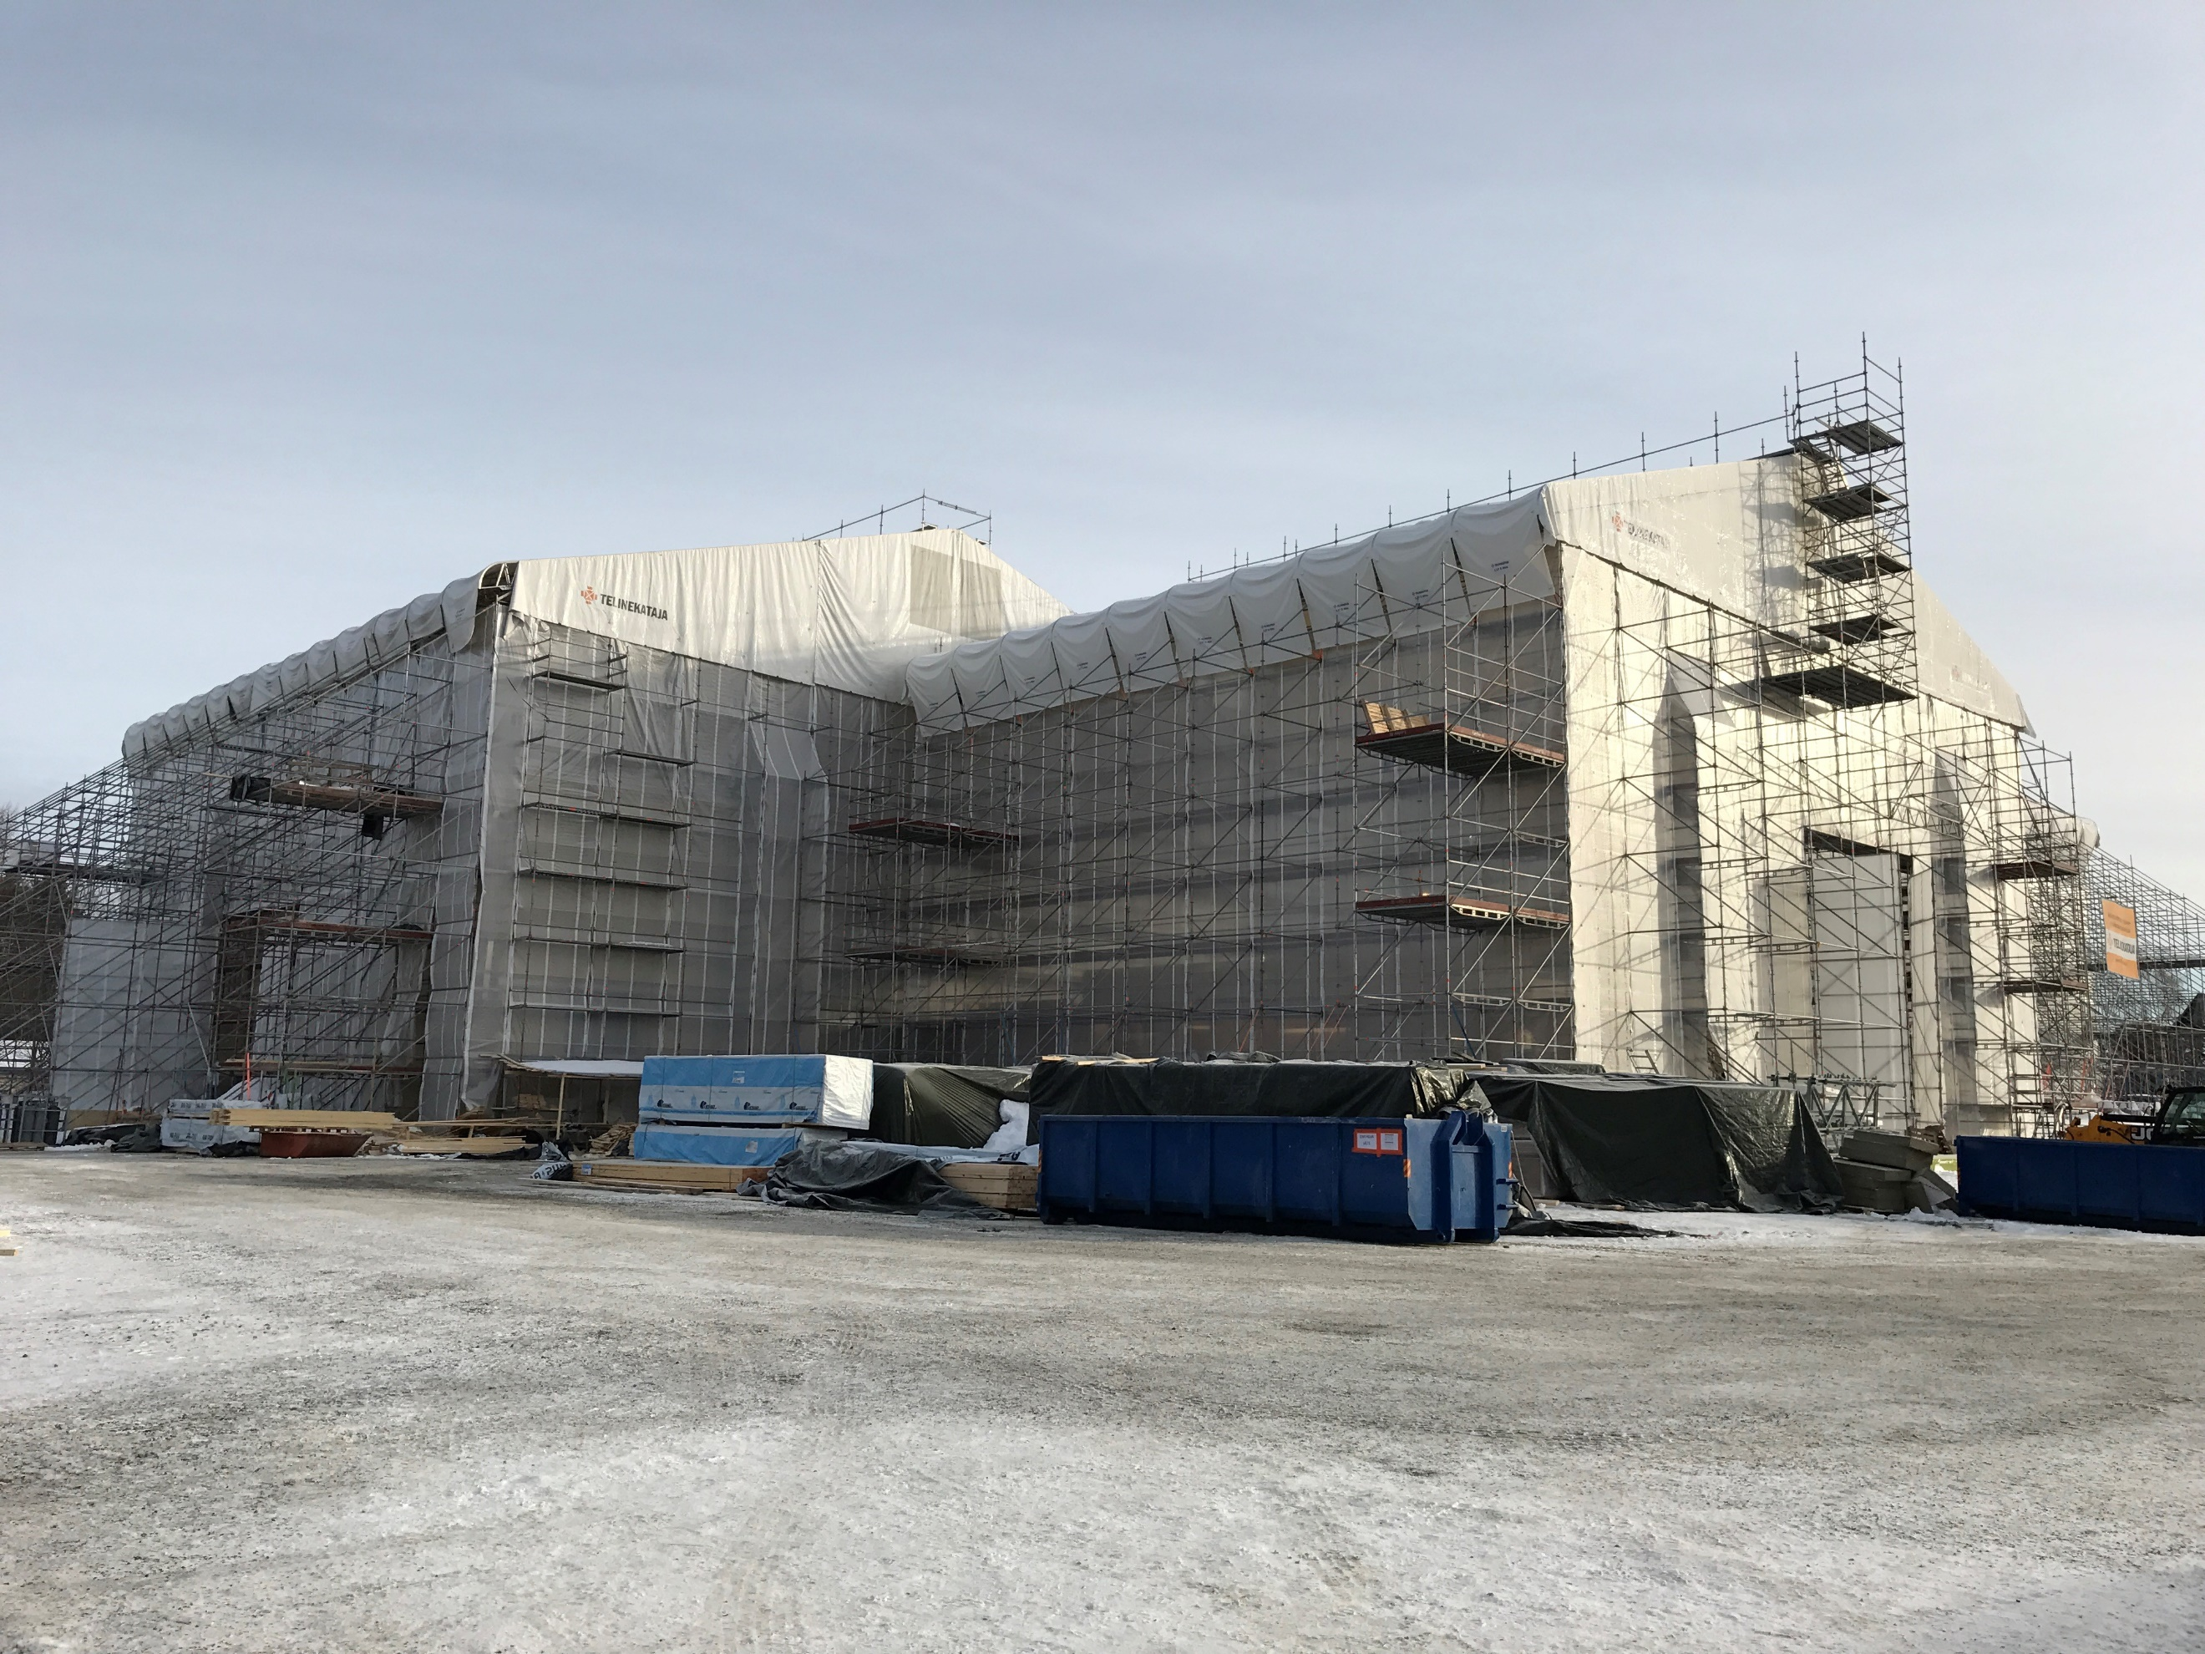
The builder decides in principle on the level of protection of the site already in the project planning phase, and the main contractor of the site plans the moisture management measures based on the set objectives. The level of protection is decided by whether the building as a whole is protected or whether the aim is to manage moisture risks by locally protecting materials, unfinished and completed structures.
Image 2 Weather protection for Tuupala wooden school, Kuhmo, Finland
Designers must consider the moisture stress of the structures during construction and design the structures so that the structural moisture can be removed.
Protecting structures from moisture is always more effective than drying the structures, so the overall protection solution includes a weather protection hall covering the entire building and the associated facade protection. Protective covers are used for local protection, as well as various protective structures to be built. To minimize the risks of moisture at the construction site, at least the work phases and structures open to weathering and the construction materials required on the construction site are protected.
The exterior cladding of the building must be closed before starting the interior work. Special attention is paid to the tightness of the openings and bushings in the water roof before starting the interior work. When the outer casing is tight, the heat can be turned on to speed up drying. Work steps that cause significant moisture stress, such as large surface castings, or leveling work, are completed before installing moisture-sensitive materials. As the site progresses, for example, dust-causing work is rhythmic so that the finishing phase work can be done in dust-free conditions.
Building materials and structures get damp for a variety of reasons. Damage to the protective materials or water leaks due to a piping failure quickly wet the structures, as well as structures that are poorly protected from rain and snow or currents caused by surface water flooding. Wetting of materials and structures caused by wet soil, soil moisture, or water used on-site and condensation of water vapor is also often overlooked. In addition, it should be remembered that many structures or building materials use even large amounts of water, which, when the structure dries, condenses on cool interior surfaces in a poorly ventilated space.

Work management
People are very rarely identical with each other, as their differences arise from history, background culture, and personality. People do not always understand each other or interact with situations in exactly the same way but have to interpret each other and situations. Only less than 10% of the human interaction situation is words and speech, the rest are expressions, gestures, sound weight, and body postures. Indeed, much of the challenge of communication and interaction stems from misinterpretations. They also give rise to feelings that lead to less constructive decisions.
Management includes all the guiding or evaluative activities that are performed in the organization to specify the goals and objectives, to maintain the operating conditions, and to guide the activities according to the set goals. The basic task of management is to support the activities of the organization and create the best possible conditions for high-quality and productive work.
Leadership can be divided into leading people and managing things.
Leading people is always interactive, influencing human behavior, which includes i.e. work management, management of the team network, as well as subcontractors and subcontractors, scheduling, and rhythm of work.
Case management includes planning management, timeliness of material comparisons (i.e. JOT), maintaining an electronic database, managing and storing incoming data.
Directive 96/71/EC (document 31996L0071) and §13 of the Finland’s Occupational Safety and Health Act 738/2002 on work planning:
The design and dimensioning of the work must take account of the physical and mental conditions of the workers to avoid or reduce the damage or danger to the safety or health of the worker caused by the workload.
The qualities of a good supervisor include motivating and committing staff to a basic task and goals, appreciating good leadership and wanting to be a people leader, and being able to share information clearly and have good self-control, be planned and anticipate, and have a sense of work goals and objectives.

List of references
Koskenvesa, A., Sahlstedt, S., Mäki, T., Kivimäki, C., Lahtinen, M., Junnonen J. & Viita, J. Laadukasta rakentamista. Työmaan hyviä käytäntöjä. 2015. Espoo: Mittaviiva Oy. Talonrakennusteollisuus ry. Available: https://www.rakennusteollisuus.fi/globalassets/laatu/laadukasta_rakentamista_2015_netti_isbn_.pdf
Koskenvesa, A., Sahlstedt, S., Lindberg, R., Kivimäki, C., Koistinen, L., Palolahti, T. & Lahtinen, M. Toimiva työmaa. Hyvät käytännöt. 2014. Espoo: Mittaviiva Oy. Talonrakennusteollisuus ry. Available: http://www.paremmanlaadunpuolesta.fi/uploads/8/1/2/2/81220848/toimiva_tyomaa_2014.pdf
Ratu 0431. Vesikaton vedeneristys. Menekit ja menetelmät. 2015. Helsinki: Rakennustieto Oy
Työturvallisuuslaki. 2002. 01.01.2003/738
Directive 96/71/EY. Document 31996L0071. 1996. 16.12.1996.

