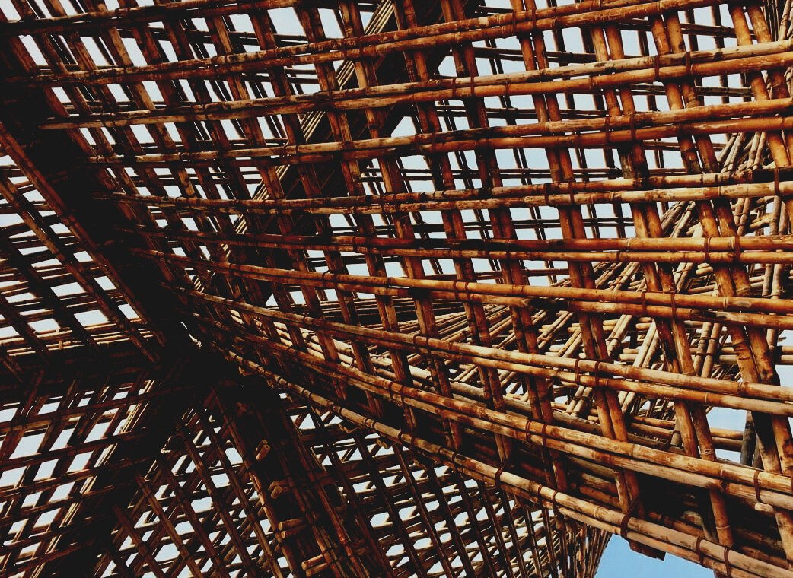

ASSESSMENT MATERIAL

Learning Unit 2
GENERAL INSTRUCTIONS FOR THE USE OF WOOD MATERIAL AND WOOD BASED PANELS
UPWOOD
Up-skilling construction workers in wood construction methods for energy-efficient buildings

UPWOOD-PUU
Rakennustyöläisten ammattitaito energiatehokkaiden rakennusten puurakentamisenmenetelmissä

Table of contents
1. Frequently asked questions 2
2. Multiple choice questions 3
3. Case studies 4
3.1 Case study 1 4
3.2 Case study 2 4
3.3 Case study 3 4

Frequently asked questions
Question: At what temperature is heat-treated wood processed?
Answer: +170-+230 °C.
Question: What are Class A and Class AB impregnation used for?
Answer: Class A in concrete and water contact and Class AB in structures above ground level.
Question: What is the difference between quality and strength classification?
Answer: The quality class is determined by the appearance of the sawn wood and the strength class by the properties related to the strength of the wood, which often also affect the appearance.
Question: What is typical for an engineered LVL product?
Answer: Laminated Veneer Lumber in this context means veneer for load-bearing structures that complies with standard SFS-EN 14374.

Multiple choice questions
- What CE marking means in products?
  - The product is China Exported.
  - It ensures that product fulfills the environmetal matters. Therefore the product can be exported and sold freely on European internal market.
  - CE marking conforms in-house quality control. Certification, inspection and testing is done by a notified body. Therefore product can be exported and sold freely on European internal market.
- Timber is a general term for:
  - All sides sawn and planed wood.
  - Round wood as well as sawmill and planing mill products.
  - At least three sides planed wood.
- On heat-treated wood, following changes can be seen:
  - Color of the wood changes to light brown, stiffness increases and biological durability is improved.
  - Flexural strength increases up to 30%.
  - The surface of wood corresponds to a wood which has dried over hundreds of years.

Case studies

Case study 1
Sawn timber sawing methods include core-free sawing, core and surface product sawing. Describe the differences between the products.

Case study 2
The concepts of surface roughness can be determinated with different methods, including coarse planing, smooth planing, fine-sawn and dimensioned sawn timber. How coarse and smooth planing affects the surface of sawn timber? What are the key differences of these two methods?

Case study 3
Heat treatment is a processing method to create generally a weather resistance timber. With the naked eye, heat-treated wood looks like if it has been dried for dozens of years. The color is from light brown to dark grey. Where have you seen a heat-treated wood being used? Why is it suitable for that use case?

